# Tosca CI Jenkins execution for multiuser and reports creation using TCS

### Step-1:-

## Tosca CI Configuration

Navigate to tosca CI folder in your workspace, If you are not able to see the folder then copy paste from below path to your workspace  
Path:- *C:\Program Files (x86)\TRICENTIS\Tosca Testsuite\ToscaCommander*

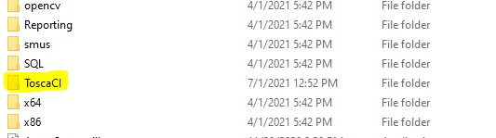

Give the path of your TWS file in “ToscaCIRemoteExecutionService.exe.config” and “ToscaCIClient.exe.config”. Also give the multiuser with which you will login.

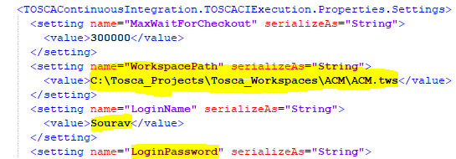

After changing above files Run “ToscaCIRemoteExecutionService.exe” as an administrator. If your getting below message, then Tosca CI has been setup successfully.

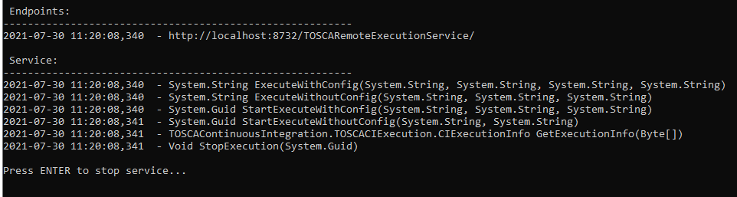

Step-2:-

## Setup the TCS file and create a Reports folder for storing runtime report.



Step-3:-

Create the testType by logging in as administrator and giving the value in the PropertiesDefination

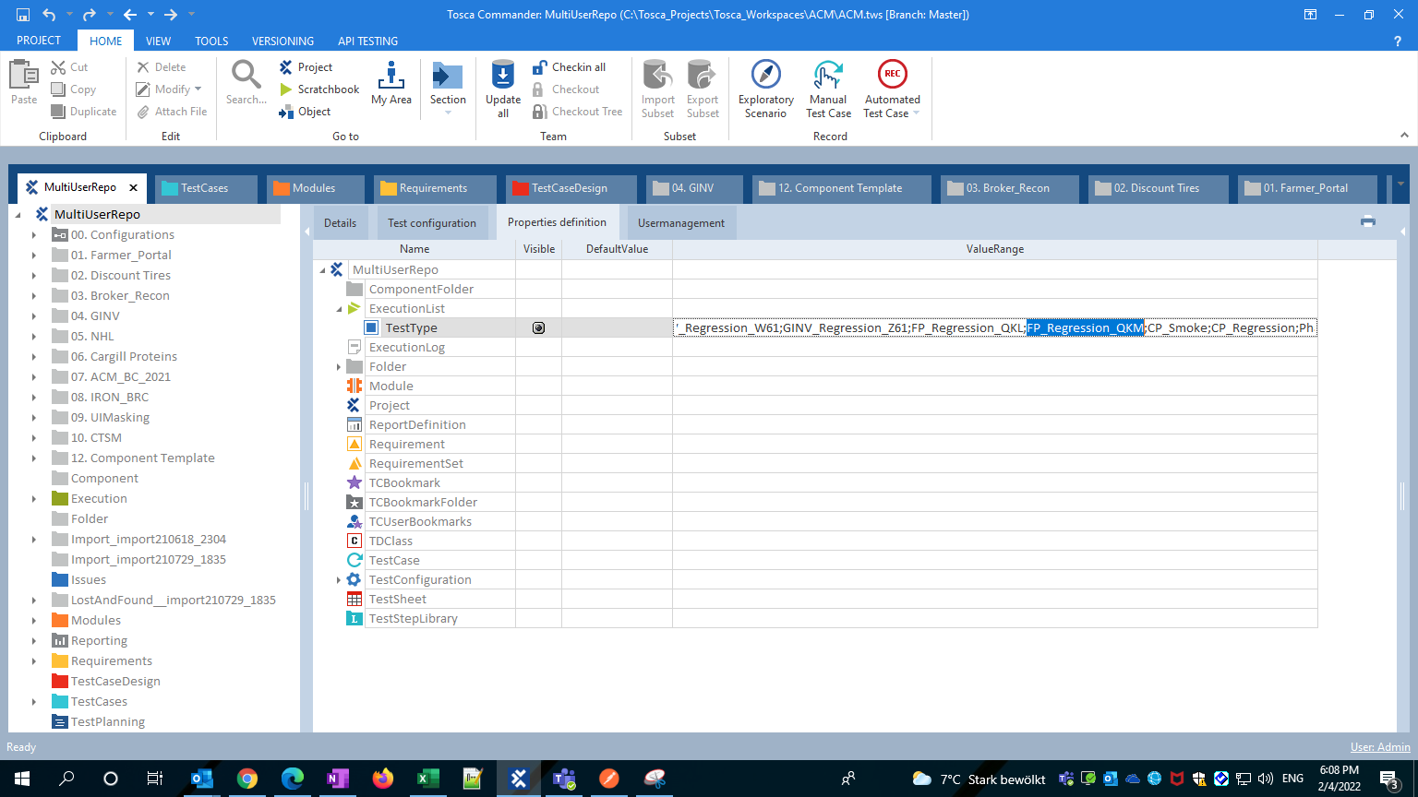

Give the test type for which you want to run

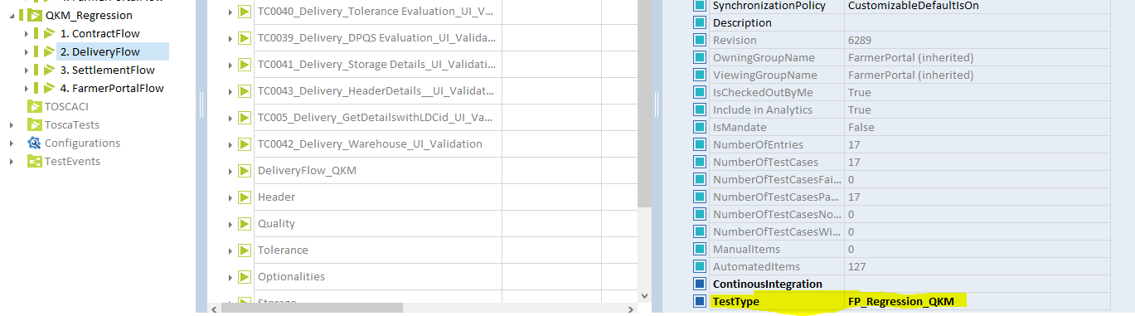

## Setup Config File

<?xml version="1.0" encoding="utf-16" ?>

<testConfiguration>

<buildrootfolder>FarmerPortal</buildrootfolder>

<customProperties>

<property name="TestType">FP_Regression_QKM</property>

</customProperties>

</testConfiguration>

Step-4:-

# Place all the files in the workspace for the Jenkins to use

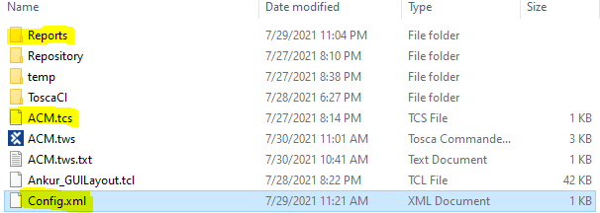

Create Build root folder and mark continuous regression as true for the list you want to run.

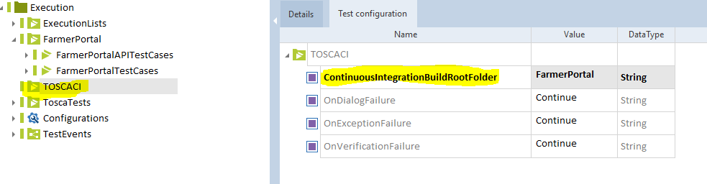

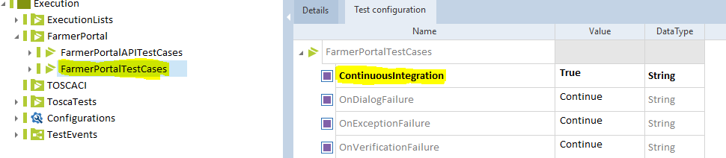

# Step-5:- Setup Jenkins

5.1 Create node where the script will run

## 1. Add Remote Server as Jenkins Node

In order to trigger the Tosca Scripts Execution, we need first connect remote server as Jenkins Node

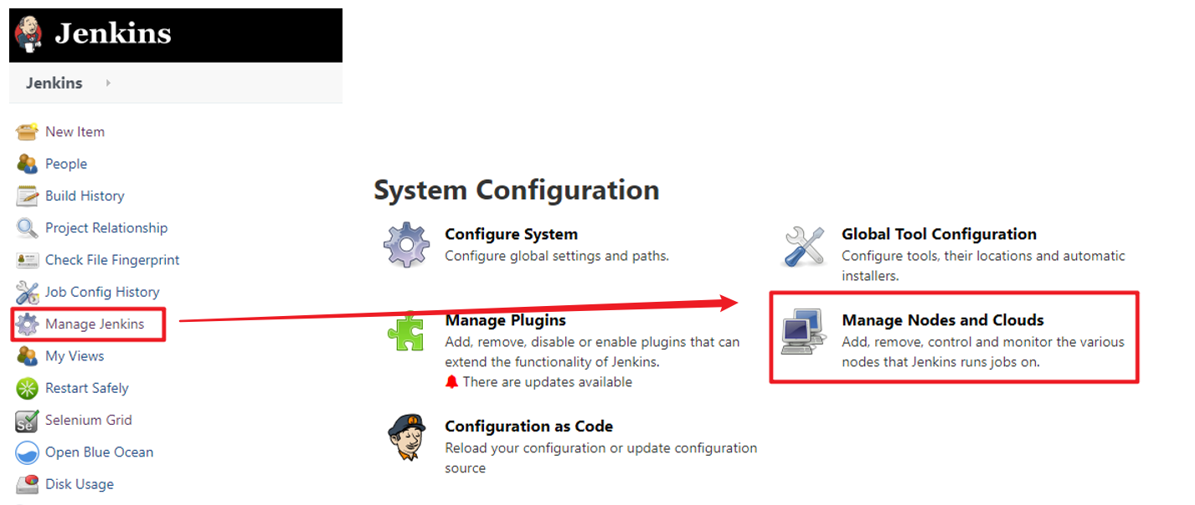

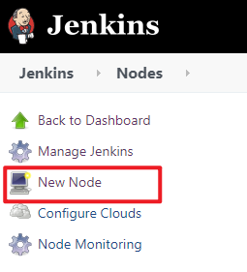 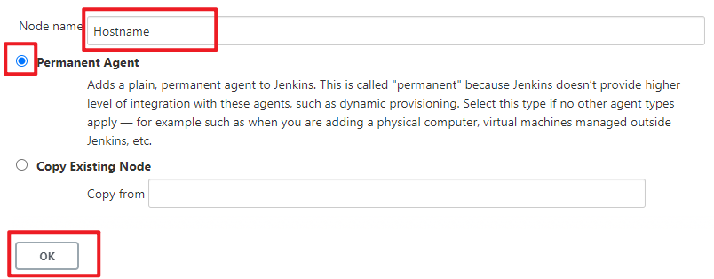

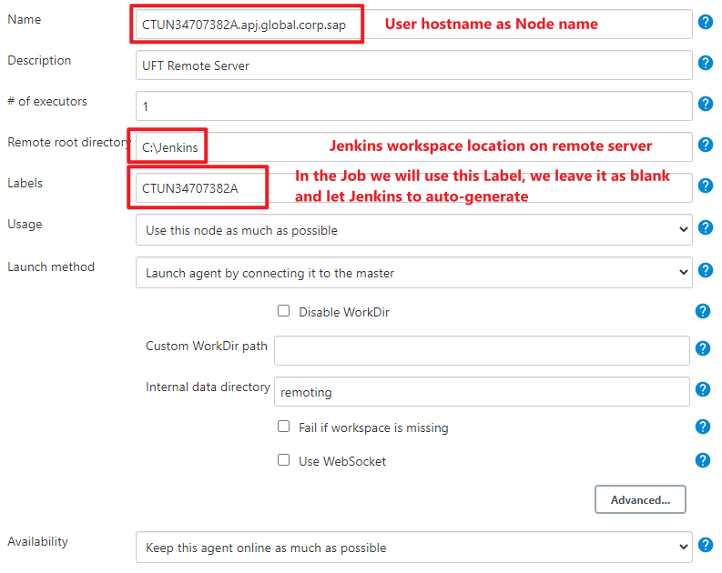

5.2 Create Job for the run

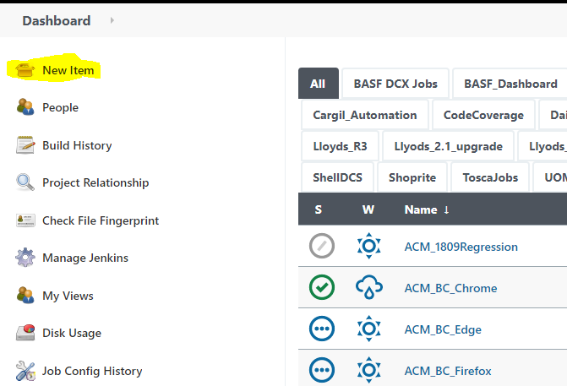

Name the Job and click on ok

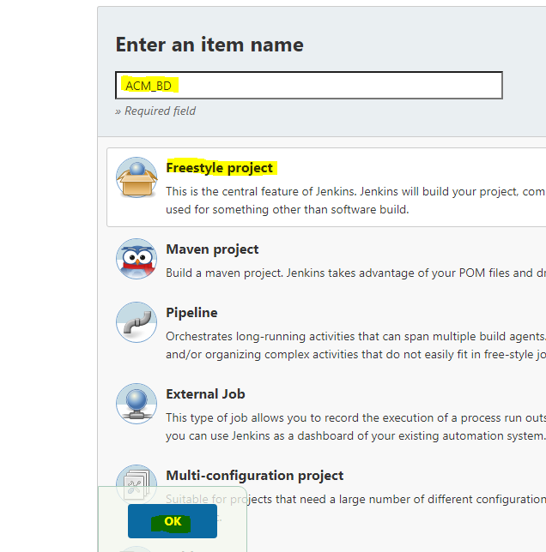

# 5.3 Setup job in Jenkins

Command :-

del .\Reports\*.* /Q

".\ToscaCI\Client\ToscaCIClient.exe" -m local -c ".\Config_QKL.xml" -r ".\Reports\result.xml"

TCShell.exe -workspace ".\ACM.tws" -login "Admin" "" ".\ACM_QKL.tcs"

